6.3 Prepare: Practice Connecting MySQL & PHP

1. Execute connect.php in your browser and submit a screenshot of the notification that you have connected to the database.Graphical user interface, text, application, chat or text message

   Description automatically generated
2. Execute testconn.php in your browser and submit a screenshot of the notification that you have successfully executed the database connect from another script.

1. Execute create_temp4.php in your browser and submit a screenshot of the notification that you have successfully created temp4.

1. Enter MySQL and submit a screenshot showing the columns of temp4.

1. Execute drop_temp4.php in your browser and submit a screenshot of the notification that you have successfully dropped temp4.

1. Enter MySQL and submit a screenshot showing the columns of temp4.

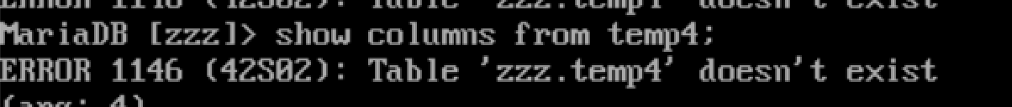

1. Enter MySQL and submit a screenshot showing that temp4 has been dropped.



1. Execute create_temp4.php again in your browser and submit a screenshot of the message showing that you dropped and created a table as many times as you wish.

